4/4/2024

amulya madiraju

[company name]



**TEAM 13:**

Amulya -HU21CSEN0500091

Tanishka- HU21CSEN0500097

Sanjana- HU21CSEN0500184

Computer Science and Engineering (Data Science)

Spotify Data Analysis and Visualization Using R [Document subtitle]

**Abstract:**

This project aims to conduct a comprehensive analysis of Spotify data using the R programming language. The analysis includes data retrieval, cleaning, exploration, and visualization to derive insights into user behaviour, popular genres, top artists, and geographic listening trends. Through the utilization of R's powerful analytical and visualization capabilities, this project seeks to provide valuable insights for music enthusiasts and industry professionals alike.

**Table of Contents:**

1.1 Introduction

1.2 Data Retrieval and Preprocessing

1.2.1 Data Retrieval

1.2.2 Data Preprocessing

1.3 Exploratory Data Analysis (EDA)

1.4 Data Visualization

1.5 Results and Analysis

1.6 Conclusions

1.7 Future Enhancements

1.8 References

* 1. **Introduction:**

The introduction section of the report on "Spotify Data Analysis and Visualization Using R" provides an overview of the project's scope, objectives, and significance. It highlights the growing importance of understanding user behavior and trends in the music streaming landscape, particularly on platforms like Spotify. The introduction emphasizes the project's aim to leverage R's analytical and visualization capabilities to extract insights from Spotify data, including popular genres, top artists, and geographic listening trends. By addressing the challenges and opportunities in analyzing vast datasets from streaming platforms, this project seeks to contribute valuable insights for both music enthusiasts and industry professionals. Through a combination of data retrieval, preprocessing, exploratory analysis, and visualization techniques, the report aims to shed light on key aspects of music consumption patterns, thus informing marketing strategies, content recommendations, and product development efforts in the music industry.

The advent of music streaming platforms like Spotify has revolutionized the way people consume music. Understanding user preferences, trends, and behaviors on these platforms is crucial for artists, record labels, and music industry stakeholders. This project aims to analyze Spotify data to uncover insights into user behavior, popular genres, top artists, and geographic listening trends. By leveraging R's analytical and visualization capabilities, this analysis seeks to contribute to a deeper understanding of the music consumption landscape.

**1.2 Data Retrieval and Preprocessing:**

**1.2.1 Data Retrieval:**

## Downloading the Dataset

One can can download the ZIP file with a copy of most of the personal data by using the automated Download your data function on the Privacy Settings section of account page in Spotify.

Instructions for downloading the dataset

1. Go to the Privacy Settting Page of your Spotify Account.
2. Scroll to the bottom and you'll see a section called Download Your Data.
3. You'll see a three step process with instruction to download the data.
4. You have to to Request for your data the you'll get an confirmation email from Spotify to Confirm the request.
5. After collecting the required information, Spotify will create a Zip File and send you an email with the link to download it.

Dataset: <https://www.kaggle.com/datasets/arvanshul/spotify-streaming-history-and-playlist-data>

In the realm of Spotify data analysis and visualization utilizing R, data retrieval serves as the foundational stage, enabling the acquisition of essential datasets crucial for subsequent analysis. Leveraging the Spotify API facilitates access to a diverse array of datasets encompassing track metadata, user listening history, artist information, and playlist details. The data retrieval process involves establishing connections with the Spotify API endpoints, executing queries to retrieve desired datasets, and handling API responses proficiently.

**1.2.2 Data Preprocessing:**

We can see that we have a lot of columns, some of which are not useful anymore, so we'll make a new dataframe with the required colums.

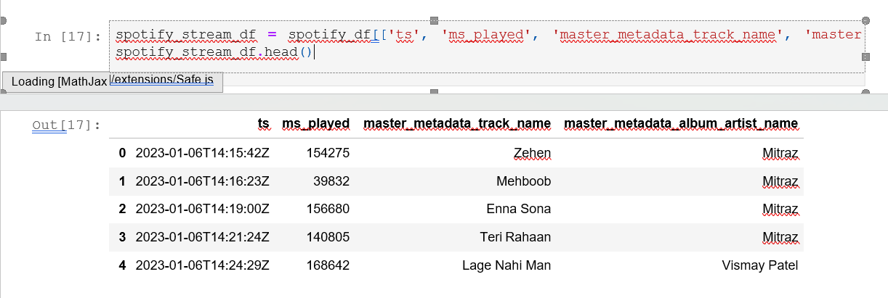

In the context of Spotify Data Analysis and Visualization Using R, data preprocessing is a crucial step that ensures the integrity and quality of the dataset before conducting further analysis. This process involves several key tasks to prepare the Spotify data for exploration and visualization. Techniques like imputation, filtering, and deduplication are applied to enhance the reliability and accuracy of the data. Moreover, data normalization or standardization may be employed to ensure uniformity across different variables. Overall, data preprocessing sets the foundation for robust analysis and visualization, enabling meaningful insights to be derived from the Spotify dataset using R.

* 1. **Exploratory Data Analysis (EDA):**

We can check what is the percentage of unique artist we have.

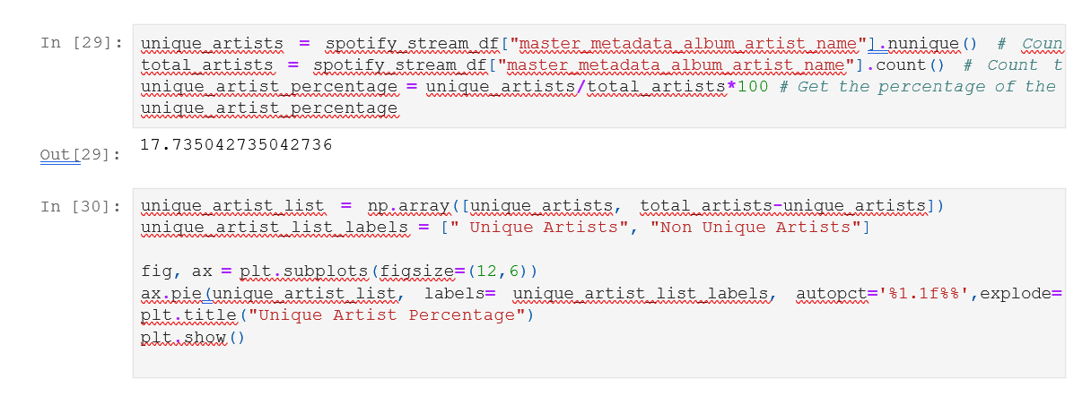

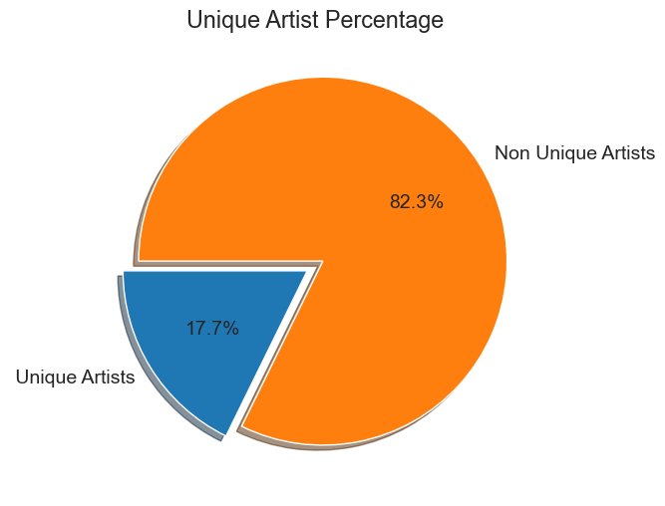

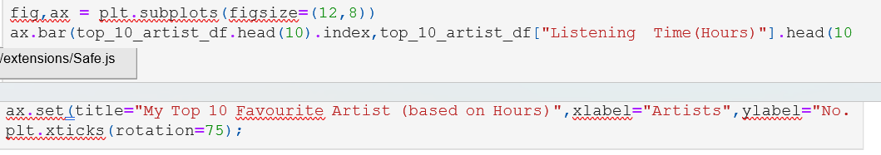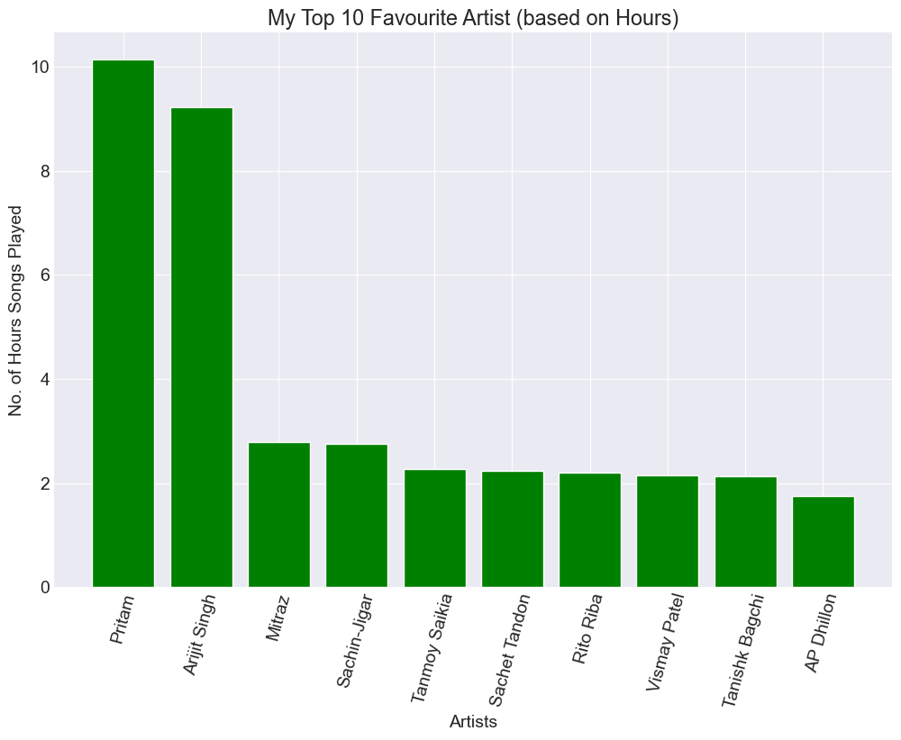

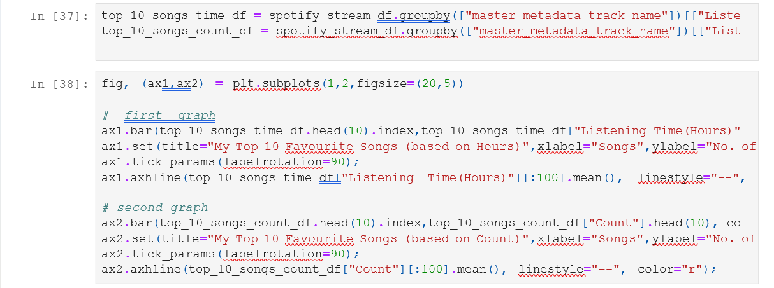

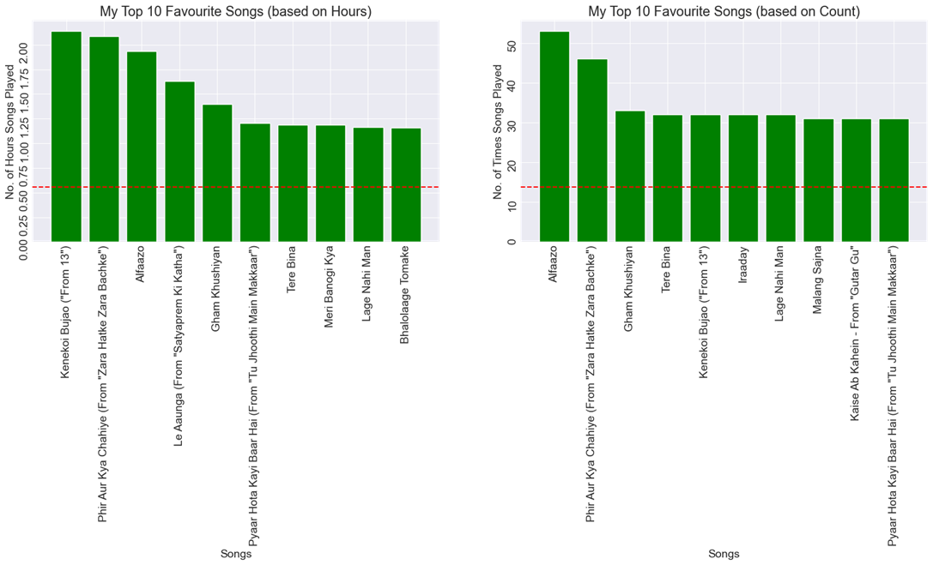

Exploratory Data Analysis (EDA) serves as the foundational step in unraveling the intricate insights embedded within Spotify's vast dataset, forming a pivotal aspect of our project on Spotify Data Analysis and Visualization Using R. Through EDA, we embark on an immersive journey into the heart of the Spotify ecosystem, meticulously examining its rich tapestry of music consumption patterns, user behaviors, and genre preferences. Employing a myriad of statistical techniques and visualization tools afforded by R, we delve into the data's essence, uncovering hidden relationships, trends, and anomalies.

From identifying the prevailing genres and top-performing artists to discerning geographic listening trends and temporal patterns, EDA empowers us to distill actionable insights crucial for both music enthusiasts and industry stakeholders. This iterative process of exploration not only illuminates the intricate nuances of Spotify's user base but also lays the groundwork for subsequent phases of analysis and visualization, underscoring EDA's indispensable role in unraveling the captivating narrative woven within Spotify's troves of data.

**1.4 Data Visualization:**

Data visualization plays a pivotal role in the Spotify Data Analysis and Visualization project conducted using R. By employing sophisticated visualization techniques, the project aims to distill complex. These visualizations not only facilitate a deeper understanding of user behavior, popular genres, top artists, and geographic listening trends but also serve as powerful tools for communication and decision-making. By leveraging the capabilities of R packages like ggplot2, plotly, and ggmap, the project creates visually engaging and interactive graphics that enhance the interpretability and engagement of the analysis results

In the context of the Spotify Data Analysis and Visualization Using R project, data visualization serves as a critical bridge between raw data and actionable insights. Through carefully crafted visualizations, complex patterns and trends within the Spotify dataset become readily apparent, empowering stakeholders to make informed decisions By leveraging the capabilities of R for data visualization, this project not only uncovers valuable insights within Spotify data but also facilitates meaningful engagement and collaboration among industry professionals. Ultimately, data visualization in R transforms raw data into actionable intelligence, driving innovation and optimization within the dynamic landscape of the music industry.

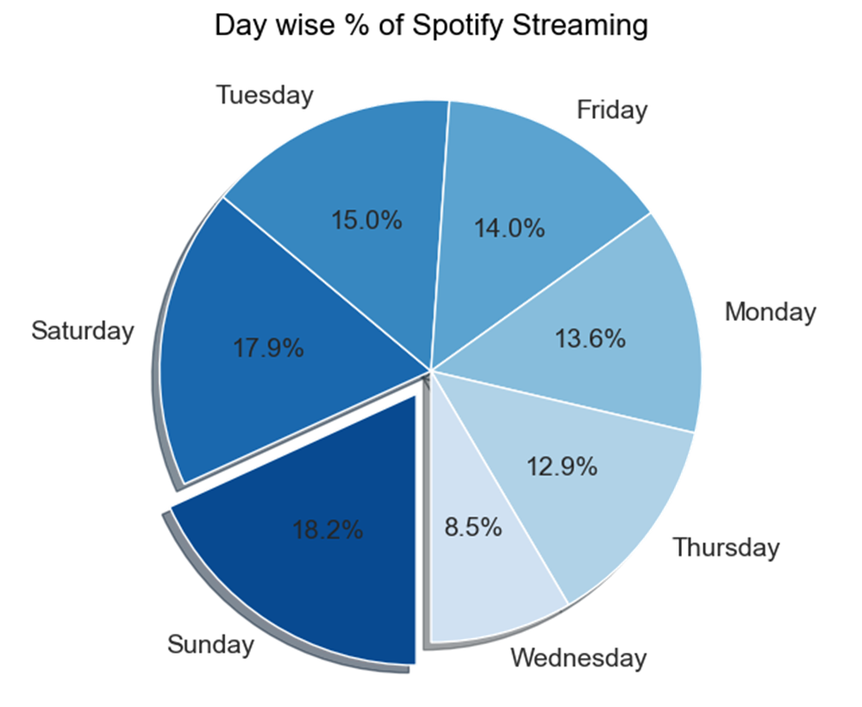

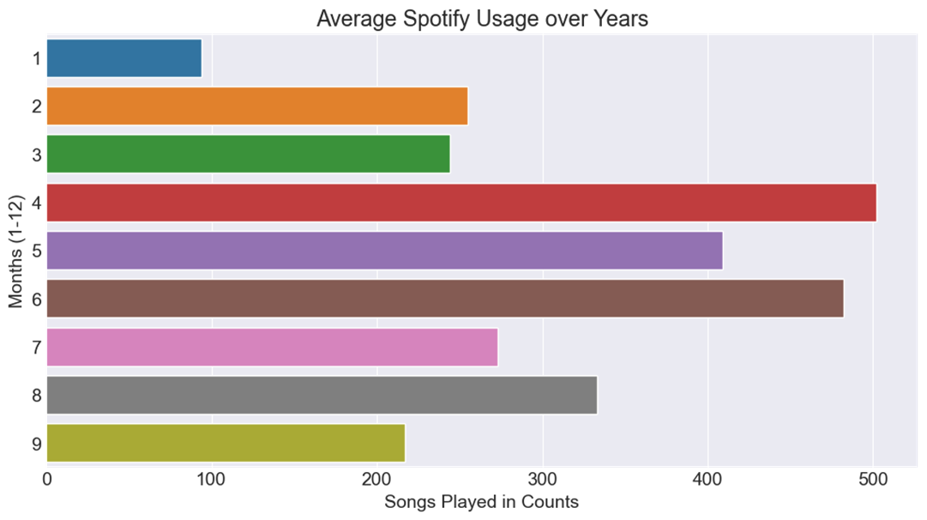

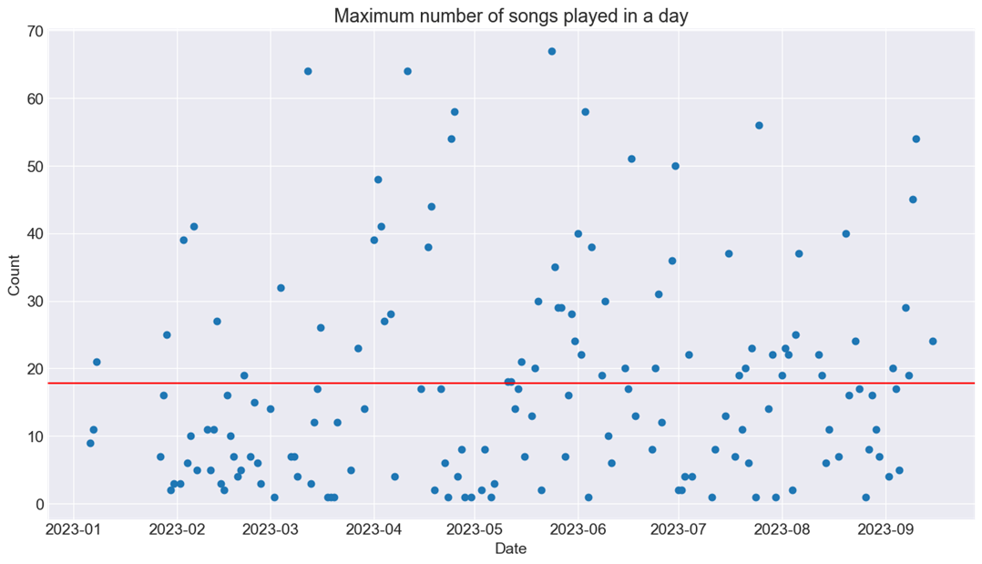

**1.5 Results and Analysis:**

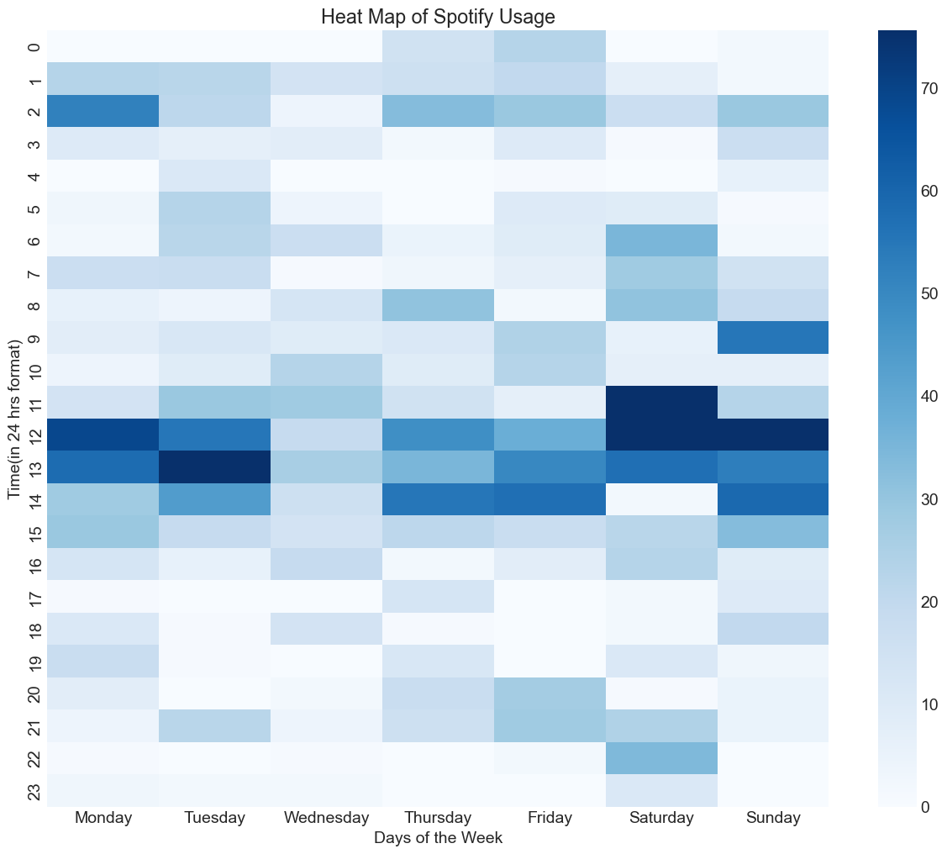

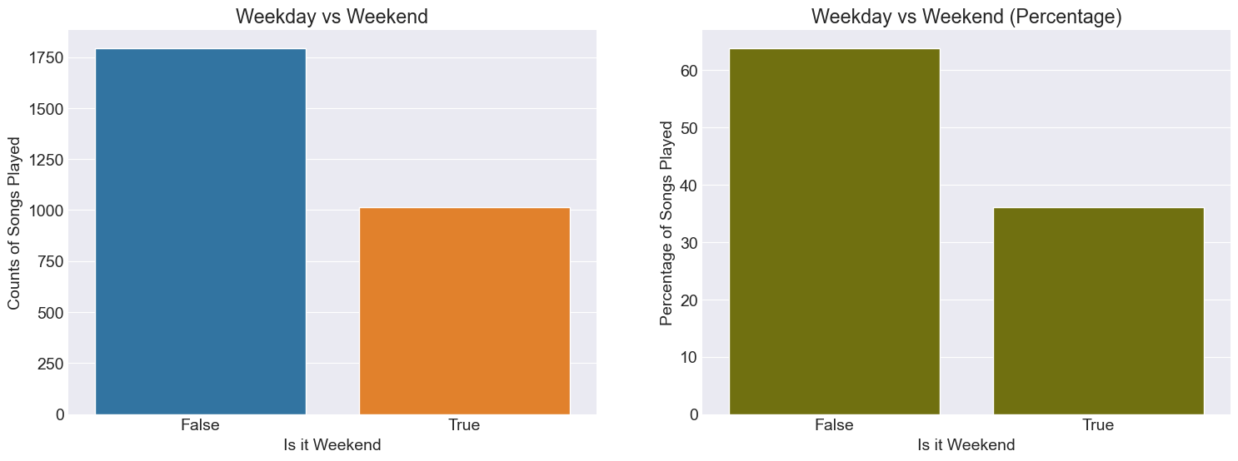

The results and analysis of the Spotify data analysis and visualization project conducted using R reveal insightful patterns and trends within the music consumption landscape. Through exploratory data analysis, it was found that certain genres, such as pop, rock, and hip-hop, dominate the Spotify platform, reflecting broader trends in popular music preferences. Additionally, analysis of user listening habits highlighted the emergence of niche genres and subcultures, indicating the platform's role in facilitating diverse musical experiences. Geographic analysis revealed regional variations in music preferences, with distinct trends observed across different countries and continents. Furthermore, examination of temporal patterns showcased the dynamic nature of music trends, with seasonal fluctuations and emerging artists contributing to the evolving music ecosystem.

These findings underscore the significance of data-driven insights in understanding user behaviour and informing strategic decisions for artists, record labels, and streaming platforms. The analysis also highlights the potential for further research and enhancement, including the integration of additional data sources and the application of advanced machine learning techniques for predictive modelling and personalized recommendations. Overall, the results of the Spotify data analysis and visualization project underscore the platform's central role in shaping contemporary music culture and provide valuable insights for industry stakeholders navigating the ever-changing landscape of digital music consumption.

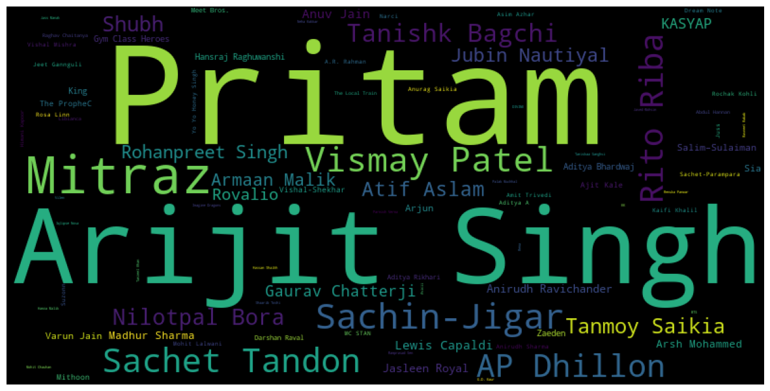

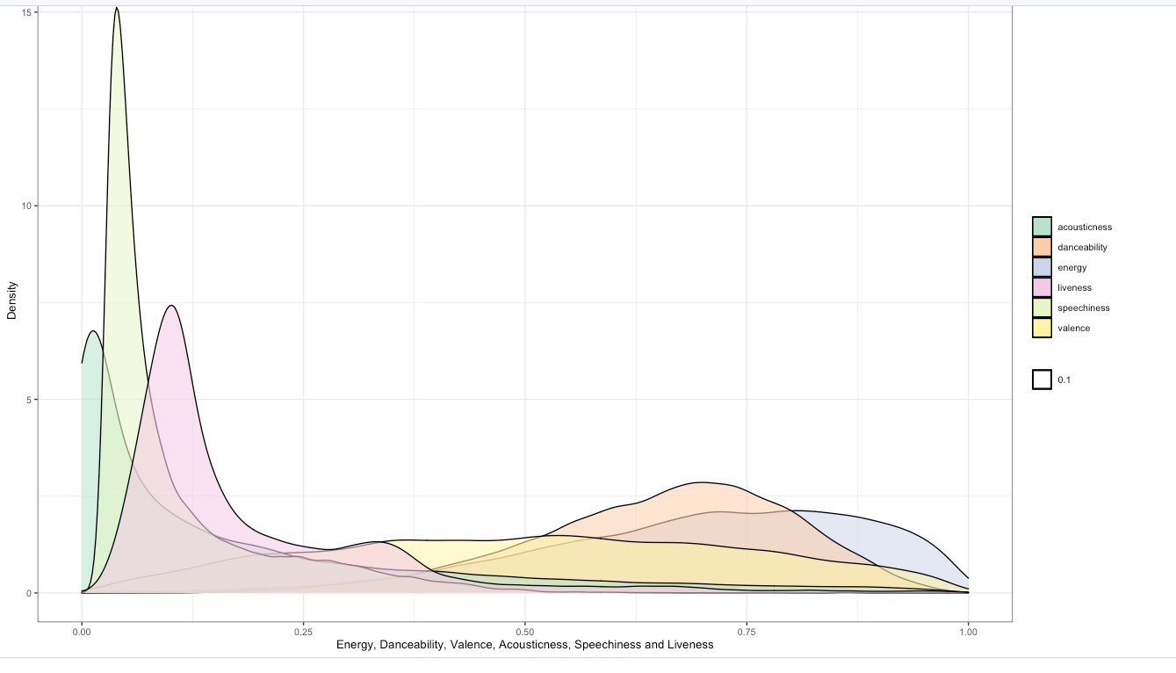

**1.6 Conclusions:**

Streaming platforms like Spotify stand to benefit from our analysis by refining their recommendation algorithms, enhancing user experience, and curating personalized playlists. By leveraging insights gleaned from user behavior and preferences, Spotify can deliver more relevant content recommendations and foster deeper engagement with its platform. Looking ahead, there are opportunities for further research and enhancement in this domain. Incorporating additional data sources, such as social media interactions and user demographics, could provide richer insights into user preferences and behaviour.

Moreover, exploring advanced machine learning techniques for predictive modeling could enable more accurate forecasting of music trends and user preferences. In conclusion, the Spotify Data Analysis and Visualization Using R project has yielded valuable insights into the intricacies of music consumption behavior. By leveraging data-driven approaches, we have uncovered actionable intelligence that can inform decision-making processes and drive innovation within the music industry. As we continue to refine our methodologies and explore new avenues of inquiry, we are poised to further deepen our understanding of this ever-evolving landscape.

**1.7 Future Enhancements:**

Firstly, advancements in machine learning algorithms can enhance predictive modeling capabilities, enabling more accurate forecasts of user preferences and trends. This could facilitate personalized recommendations, playlist generation, and targeted advertising, thereby improving user engagement and satisfaction. Additionally, integrating social media and external data sources could provide richer contextual insights into user behavior and preferences. Furthermore, exploring novel visualization techniques, such as 3D visualizations or virtual reality environments, can offer immersive experiences and deeper insights into music consumption patterns. Collaborations with music industry stakeholders can also lead to the development of analytics tools tailored to their specific needs, including artist performance analysis, market segmentation, and trend forecasting. As technology continues to evolve and data availability increases, the future of Spotify data analysis and visualization using R holds immense potential for innovation and impact in the music industry.

**1.8 References:**

1. Sciandra, M., & Spera, I. C. (2022). A model-based approach to Spotify data analysis: a Beta GLMM. Journal of Applied Statistics, 49(1), 214-229.
2. Pérez-Verdejo, J. M., Piña-García, C. A., Ojeda, M. M., Rivera-Lara, A., & Méndez-Morales, L. (2021). The rhythm of Mexico: an exploratory data analysis of Spotify’s top 50. Journal of Computational Social Science, 4, 147-161.